How to trade the 1 hour chart.

1. Setup number one, we were looking for levels of structure looking left that would provide a bounce before trend continuation.

With this strategy we will be using two very simple setups on these setups. 1. Multiple time frames 1 hour or 15 minunte chart.
2. 50 period exponential moving average.

1a. I'm looking for buy trades if the market is trading below the 50 ema.
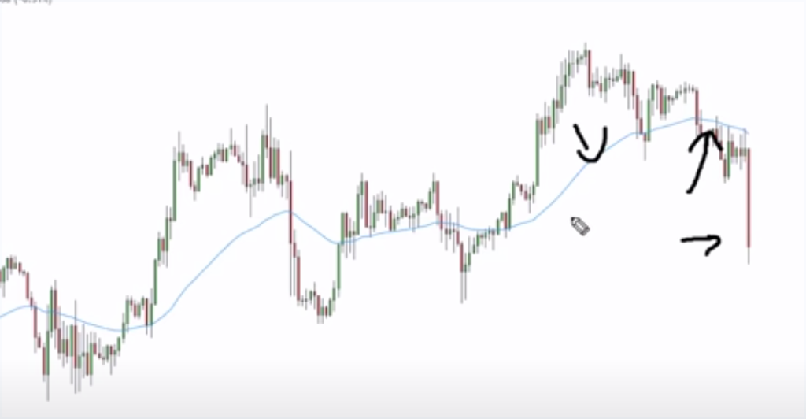

2. We're at a major level of structure that's been tested multiple times.
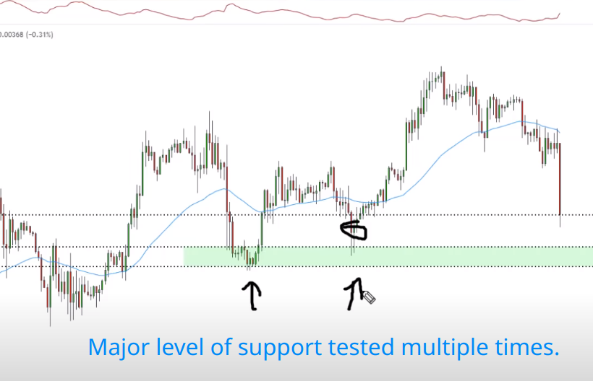
I want the lowest bodies of the support level to be touched with my box level that i draw.

2b. We're utilizing a major level of structure support.
I'm looking at this level to provide a bounce before trend continuation to the downside with that being the case, this is when we utilize lower time frame.

3. Go down to lower time frames and look for possible entries.
what are my possible entries they consist of double bottoms, hammer candles, buying pressure of some kind a big green candle would be fine.

4. After this bearish move down, bulls took over directly creating a big green candle, this candle has a lot of momentum and this candle is a place i would put a buy trade.
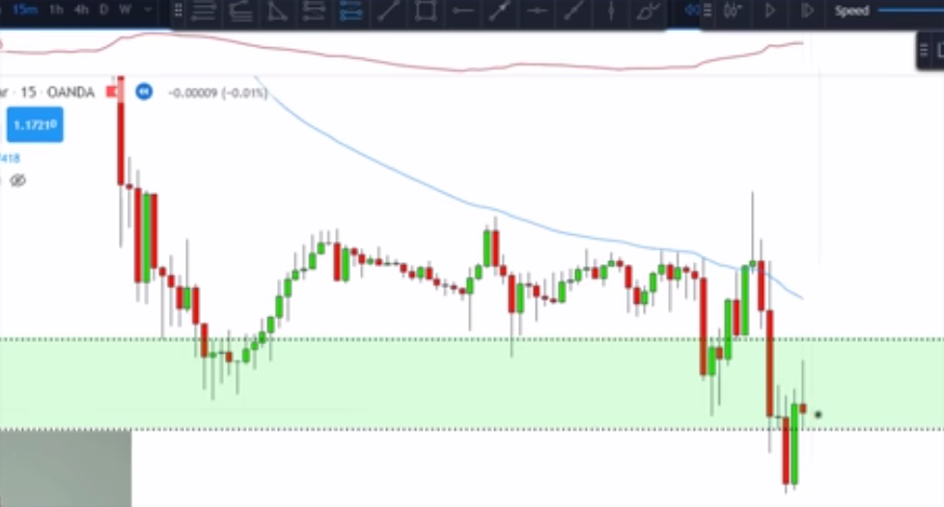

Conditions

NOTE: Don’t look for your level of support from where the pullback started,
rather look left and lower for the level of support.
I define major levels of structure as a recent level that's been tested multiple times

1. We have a market trading below the 50 ema

2. We have a market at a major structure level while we're here we're waiting on just a little bounce before the market continues in this downtrend since we're waiting on this little bounce.

NOTE: Don’t look for BUY TRADE at the level of support where the current pullback started, rather look left and then lower that is where to find the next level of support.

3. Go down to lower time frames and look for possible entries what are my possible entries they consist of double bottoms, hammer
candles, buying pressure of some kind a big green
candle would be fine.

4. Our confirmation is show me buying pressure, big green candle in this case with this big green candle i would have a stop loss below this swing low for me personally i put my risk to reward at a 1.4.
Setup number two, we're actually looking for trend continuation.

1. Rules are market must be trending below the 50 ema on a 1 hour time frame.
2. Second rule is that we have to pull back to the next major level of structure looking left that could provide resistance for this market.
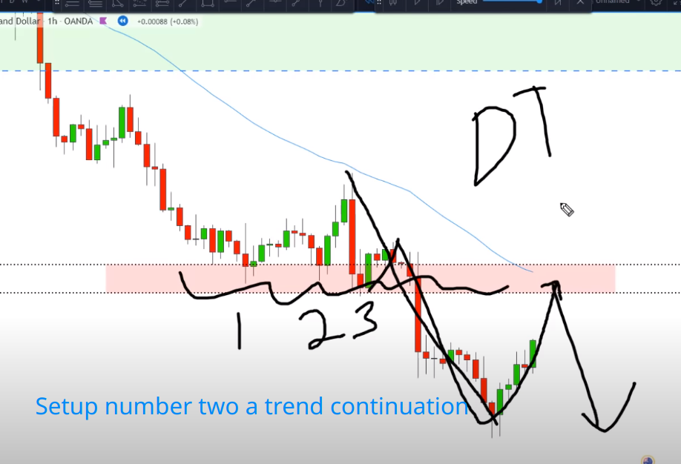
3. Now we're in our zone, I would drop down to smaller time frames that time frame would be the 15 minute or the 5 minute chart.
Her, i would drop down to smaller time frames at ths point.
3
1
2
3b. Look for selling pressure, does this look like selling pressure? it does this is a momentum candle that closes below the previous candle and most of the body of the candle is red.
3c. Another hint that it's a momentum candle is that the bottom wick is tiny. if we have a small bottom wick that means at the close of this candles bears were taking over and they didn't allow the bulls to push the candle up anymore.

Entry rules.

The trade itself here would be on the close of that candle or the open of the next candle.
We would have an entry we'd have a stop above our zone by a few pips and we would have a target like i said I normally do about a 1.4 to 1 risk reward.

